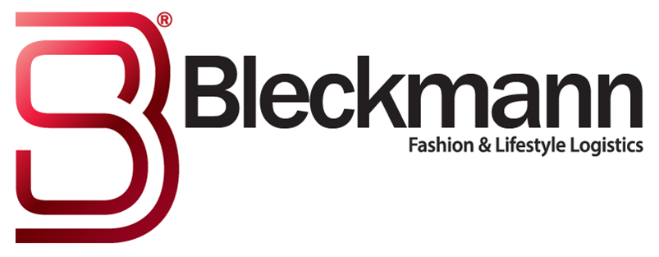
Bleckmann signs multi-year agreement with Vtech

Almelo, February 8th 2018 - Signing a multi-year agreement with Vtech continues Bleckmann growth as a logistics service provider. Bleckmann is excited with this development and looks forward to work closely together with the VTech team.
VTech is a leading global toy group that supplies high quality electronic toys throughout all regions of the world. "Our leading position in the Fashion & Lifestyle market segments has enabled us to build a tailor-made solution for VTech that best meets their unique requirements" , says Jurrie-Jan Tap, Chief Sales Officer at Bleckmann. "Services to the toy industry require a great deal of flexibility, especially in peak periods at the end of the year. At Bleckmann we recognise and understand these market expectations very well".
The VTech board announces that this collaboration is an important step in its development in the European market. To facilitate growth, VTech has been looking for a future-proof solution for its European logistics. In Bleckmann they have found a partner that fits well with their needs and creates a flexible and sustainable full supply chain solution.

Logistic hotspot
With VTech as her customer, Bleckmann will move to the new logistics hotspot in the Netherlands; T-Port Logistic Campus. The campus is part of the larger XL Businesspark Twente, a project of Groep Heylen. Bleckmann will invest in a distribution centre with a storage area of ​​more than 43,000 sq m from which the products of VTech will be distributed throughout Europe. "The T-Port Logistic Campus is a great location for us and our customer Vtech," Says Johan Milliau, CEO of Bleckmann.
"This location is accessible in many ways; by rail, by water and by road. The modern Combi Terminal Twente is just next door. This allows us to take containers from the ship directly to our distribution centre, and vice versa. This location offers great opportunities".

Employment opportunities
With the arrival of Bleckmann in Almelo over 250 jobs will be created, a great boost to regional employment. Bleckmann will soon start recruiting employees for the new distribution centre.

Note to editors
Bleckmann
Bleckmann, established in 1862, is a leader in Supply Chain Management (SCM) solutions for the global fashion & lifestyle industry. Bleckmann aims to provide its customers with the best SCM solutions. The logistics company has developed to an omni-channel service provider and has its offices in Europe, the United States and Asia, with approximately 225 million Euro revenue. More information: Marjolijn Uringa, Marketing & Communications, +31(0)623366668 www.bleckmann.com.
VTech
VTech is the global leader in electronic learning products from infancy through toddler and preschool and the world’s largest manufacturer of cordless phones. It also provides highly sought-after contract manufacturing services.
With headquarters in the Hong Kong Special Administrative Region and state-of-the-art manufacturing facilities in China, VTech currently has operations in 11 countries and regions. It employs approximately 27,000 employees. This network allows VTech to stay abreast of the latest technology and market trends throughout the world, while maintaining a highly competitive cost structure.
In 1992 VTech Electronics Europe B.V. established offices in the Netherlands, Germany, Spain and France, specializing in learning products. Since then VTech won many awards from recognized juries, educators, retailers, consumers and journalists.

