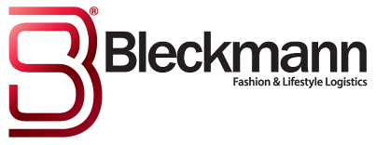
Abercrombie & Fitch and Bleckmann donate over €30,000 to Charity Foundation KiKa
Logistics service provider Bleckmann and fashion label Abercrombie & Fitch recently jointly organized a “sample sale” in which clothing and accessories were sold at attractive prices. Bleckmann provided its location and staff where Abercrombie & Fitch sold a wide variety of fashion items.
The sale resulted in a record yield of up to EUR 31,764. The organizers have decided to donate the yield to Charity Foundation Kika: a Dutch charity foundation that brings in fundings solely for research to childhood cancers.

Leo Osseweijer from Kika today received the cheque with the words: “A great amount, a record for me”

