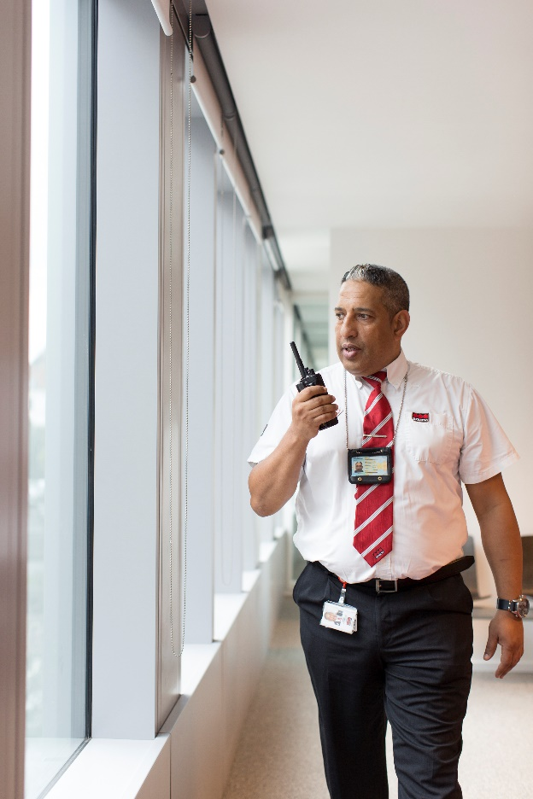

Securitas chooses Bleckmann as their e-fulfilment partner to serve 6,000 security agents in Belgium and Luxembourg

Bleckmann, the specialist in end-to-end logistics solutions for fashion- and lifestyle brands, has been chosen by Securitas Belgium & Luxembourg as their e-fulfilment partner. Bleckmann will provide a Radio Frequency Identification (RFID) technology-based fulfilment management, including the full scope of logistics services with next-day delivery, recycling of corporate clothing and returns processing. The solution will enable 6,000 Securitas agents in Belgium & Luxembourg to order, return or exchange their uniforms and other workwear safely via a dedicated e-commerce platform.
Bleckmann will process all internal orders based on RFID technology. This allows each individual piece of clothing to be identified and traced. All data will be available to the customer at all times to assure a higher level of security.
“The right type of work clothing for people with a social mission is of vital importance. This certainly applies to the security sector, where in addition immediate traceability of workwear pieces in end-to-end distribution is crucial. We cannot risk any uniforms or other items suddenly disappearing from the radar, as that would cause a direct danger to society,” says Carolle Van Dijck, spokesperson at Securitas. “Since proper managing of workwear in the security sector is a matter of absolute priority, we have partnered with Bleckmann to secure closely monitored logistics management integrated with our own internal hermetic e-commerce platform developed by Duke & Grace,” she adds.
“Preparations and set up of the solution were relatively complex, as they required not only integration with the client’s e-commerce platform, but also processing the data of all 6,000 authorised security agents,” comments Peter van Butsel, Director IT at Bleckmann. “With the introduction of the right IT systems we are fully capable of processing all operations in a highly secured IT environment,” he adds.
On top of processing orders and assuring overnight delivery to Securitas agents, Bleckmann will take care of reverse logistics and recycling of the clothing. Each agent will have access to the Bleckmann Returns Portal, integrated directly into the Securitas Webshop. It enables grading of the return product and printing a return label for sending back any pieces that are damaged or no longer in use. Bleckmann will recondition or recycle clothing according to the instructions of Securitas.
The partnership with Bleckmann and e-commerce solutions implemented by Duke & Grace enable Securitas agents to shop for their workwear with ease in a hermetic environment, while the shipment´s processing is handled with the highest attention to security. Agents are equipped with the right workwear items whenever needed while Securitas is able to better control and manage the use, shipping, swapping and recycling of corporate clothing. This is the Consumerisation of Enterprise in practice.

About Securitas
Securitas is a global leader in security and safety knowledge. Securitas combines people, technology and knowledge to deliver efficient solutions tailored to the customer. More than 370,000 employees make a difference in both the residential sector, SMEs, large companies and the public sector. Securitas has more than 7,000 employees in Belgium and Luxembourg.

About Duke & Grace
Duke & Grace combines the power of technology, creativity and strategy into innovative communication solutions. From strategic thinking to building digital platforms and designing creative campaigns.

About Bleckmann
Bleckmann is the market leader in Supply Chain Management (SCM) services for the fashion- and lifestyle brands. Founded in 1862, Bleckmann has evolved from a transport company into a full supply chain solutions provider with a specific expertise in e-fulfilment solutions. With a strong base in Europe the company has expanded to the US and Asia enabling Bleckmann to service its customers across the globe. Bleckmann’s investments and vast experience in IT solutions enable a globally unified platform for our clients. Every day nearly 4000 team members support Bleckmann customers to deliver on their promises. With over 350 million Euro revenue, Bleckmann has the scale and flexibility to create world class solutions that delight its customers. For more information, please visit www.bleckmann.com

In case of questions, please contact:
Dorota Tankink | Marketing & Communication Executive | +31 6 3012 9759 | dorota.tankink@bleckmann.com

