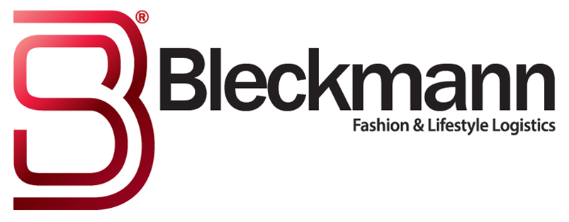
Bleckmann’s new entrance in Top 10 at Emerce 100

Emerce 100 is an image research for the best companies in e-business. The thirteenth edition of Emerce100, a special annual edition of Emerce, was published earlier this month. It shows how decision makers, in the field of online marketing, ICT and e-business have assessed the performance of service providers in the e-business and marketing sector for the past year.
The Emerce100 is no longer limited to just 100 companies. This year the number stands at no less than 632, an increase of 72 companies compared to last year. This is due to ever growing number of specialisms and providers in the e-business market.
In the category Fulfillment warehousing, Bleckmann comes in at number 5, with a 4.5 star rating. A wonderful compliment from our customers!
Especially since Bleckmann is a full service provider (3PL) and the Top 10 is dominated by fulfillment only parties.

