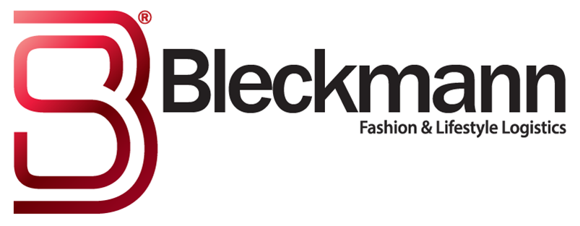

Bleckmann Distribution Centre Fast Tracks European Development for
Billion Dollar Fashion Business

February 20, 2017 - Logistics service provider Bleckmann and fashion giant Techstyle are celebrating the opening of a new distribution facility in Venlo, The Netherlands, which will ship thousands of orders a day direct to JustFab and Fabletics customers all over Europe. Stephan Satijn, Vice Mayor of Venlo, officially opened the new facility this morning.

Venlo is a well-known European logistics hotspot and the opportunity to partner with Techstyle has allowed Bleckmann to fast-track its investments in the area explains Steven Rymenans, Strategic Director of Bleckmann, who is responsible for the company’s international development: "Our customers are increasingly delivering direct to the final consumer. We have become an omni-channel service provider and future-oriented fashion and lifestyle brands are finding us in increasing numbers. With its access to an extensive road network to surrounding countries, Venlo is the perfect fit for our business." Satijn is also pleased with the settlement of the two strong companies. “The operation has created around 130 new jobs, which is a good development for our region.”

US fashion business Techstyle has seen impressive growth since its launch, earning unicorn status in 2014 with a USD 1 billion valuation. To enable further development in Europe, the company has been looking for a logistics partner with expertise in fashion and e-commerce along with a strong distribution network. Gerrit Müller, GM Europe for Techstyle, is responsible for the European development of the company’s brands: “Our new operation with Bleckmann in Venlo enables us to further develop our presence in Europe. Together with Bleckmann we have set up the new facility in record time allowing us to be fully operational for our busiest months of the year”.

One of the conditions of the partnership was the speed of set up - the entire operation needed to be up and running within six weeks. Rymenans adds: "This is just the start of our journey in Venlo. Our new 18,000 sq m facility provides an important platform for further and faster growth of our business within the European market. In the coming months, we will be introducing more fashion and lifestyle clients to our Venlo facility."
-Ends-

- Notes to Editors -
About Techstyle Fashion Group (formerly JustFab inc.)
TechStyle Fashion Group is a global fashion and lifestyle company founded in 2010 to deliver access, quality and style for unprecedented value. TechStyle Fashion Group uniquely merges advanced technology with the latest fashion trends to offer an entirely new shopping experience to millions of customers worldwide, including 4 million VIP Members, through a portfolio of apparel and shoe brands. TechStyle Fashion Group is reimagining the business of fashion through data, personalization and vertical integration to benefit the modern shopper. TechStyle Fashion Group’s brands include JustFab, Fabletics, ShoeDazzle and Fabkids, and are available in the US, Canada, the United Kingdom, Germany, France, Spain, Sweden, Denmark and the Netherlands. www.TechStyle.com
About Bleckmann
Bleckmann, established in 1862, is a leader in Supply Chain Management (SCM) solutions for the global fashion & lifestyle industry. Bleckmann aims to provide its (end)customers the best SCM solutions. The logistics company has developed to an omni-channel service provider and has its offices in Europe, the United States and Asia, with around 200 million euro revenue. More information: Loes Windt, Marketing & Communications, +31 (0) 613181560, www.bleckmann.com

