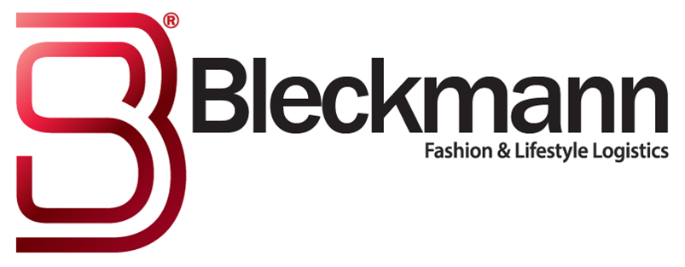
PRESS RELEASE
4 July 2017
The UK’s fastest growing online fitness brand appoints new global logistics provider to support international expansion
Bleckmann Logistics UK, a leader in fashion and lifestyle logistics, has secured a five-year contract to manage the entire logistics and e-commerce supply chain for UK headquartered Gymshark Ltd, the UK’s fastest growing online fitness apparel brand. Bleckmann acquired a new 100,000 sq ft warehouse facility in Swindon to service Gymshark’s current and future logistics requirements.

Over the duration of the contract, Bleckmann will be responsible for managing all aspects of the company’s logistics requirements globally, from source to delivery.

Gymshark, established in 2012, sells its own manufactured products online in 171 countries. Sales have increased dramatically over the last four years to a predicted £41m turnover in its latest financial year. The company has also recently been ranked number one by The Sunday Times out of the hundred fastest growing companies in the UK.

Key to the company’s success has been its use of digital media channels, which is integral to its strategy of treating customers around the world as part of its global family. Gymshark sponsors 18 top global YouTubers, Instagrammers and bloggers who accompany the business to major fitness exhibitions around the world and reach out to some 20 million social media followers.

Steve Hewitt, Chief Executive of Gymshark, said: “We have reviewed our supply chain requirements in line with our significant growth ambitions. It is critical that we have a logistics service which can support both our plans and our drive to offer the best possible customer experience. In today’s real time digital world, consumers’ expectations are understandably high and we have to meet them wherever they are based across the globe. Also as a company that has innovated over 100 new products this year alone, we need a logistics operation that is agile to meet the supply chain requirements of these launches.

“The Bleckmann track record and existing customer base, along with their own “can do attitude” has given us the confidence that they are the right partner to support the expansion of Gymshark into the future. We look forward to welcoming them into the Gymshark family.”

Steven Rymenans, Strategy Director of Bleckmann and responsible for the international development of the company, is also proud of the collaboration and added: “We are truly delighted to partner with Gymshark, and know we have the global solutions in place to support the company’s focus on international growth and development from any one of the Bleckmann sites around the world. We, as a business are so proud that the board of Gymshark chose Bleckmann to be their e-commerce and logistics partner, it has truly been a team effort."

Notes to Editors
Gymshark is the fastest growing UK company and one of the most recognisable fitness brands. Its apparel and accessories are worn by those running on treadmills, pedalling on exercise bikes and pumping iron in fitness centres all over the world, generating revenues for the company close to £13m in 2016 and set to increase more than threefold by the end of its 2017 financial year to circa £41m. For more press information, please contact Chris Lawrance, JBP PR, on 0117 9073414/0774 7693905.

Bleckmann, established in 1862, is a leader in Supply Chain Management (SCM) solutions for the global fashion & lifestyle industry. Bleckmann aims to provide its customers with the best SCM solutions. The logistics company has developed to an omni-channel service provider and has its offices in Europe, the United States and Asia, with approximately 210 million Euro revenue. More information: Loes Windt, Marketing & Communications, +31 (0) 613181560, www.bleckmann.com.

